Gabriel Hartman

7/20/2025

NWIT291

Professor Lemma

Installing FoxyProxy on Private Window for FireFox

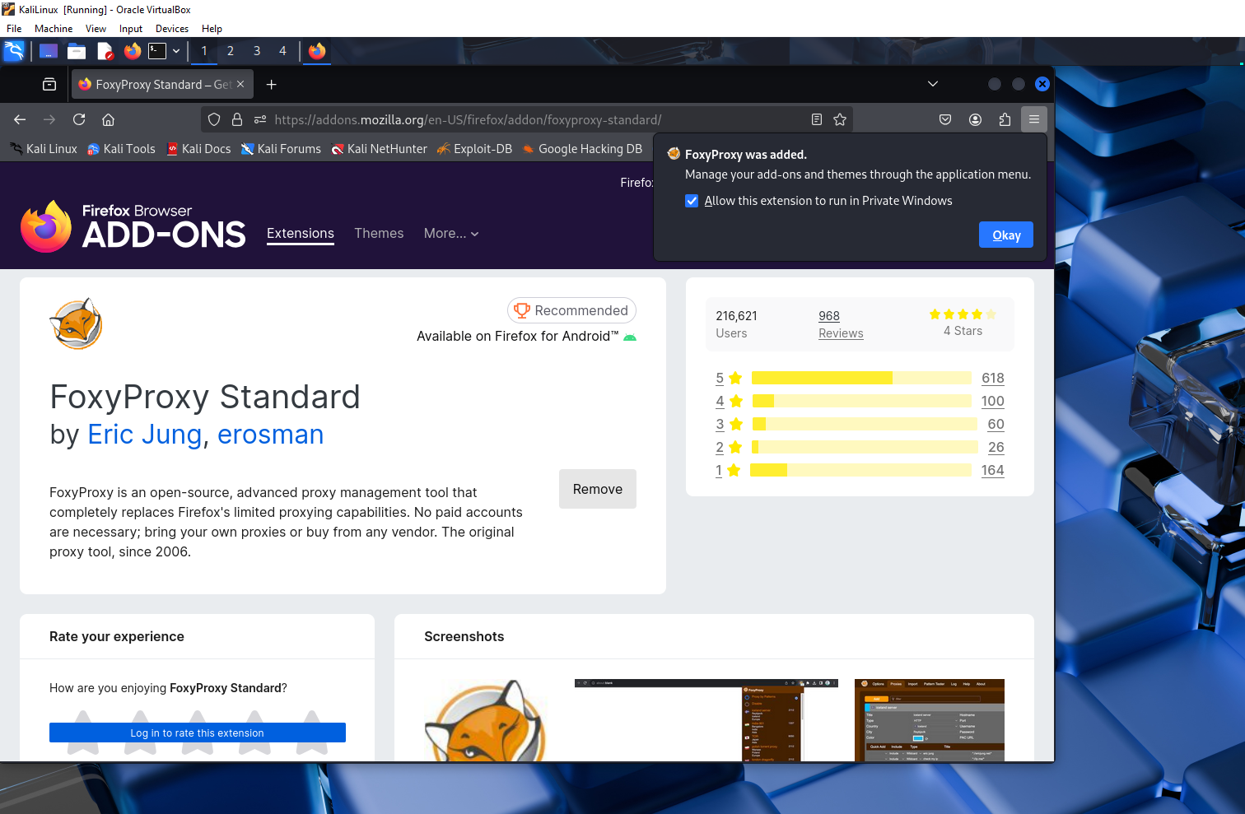

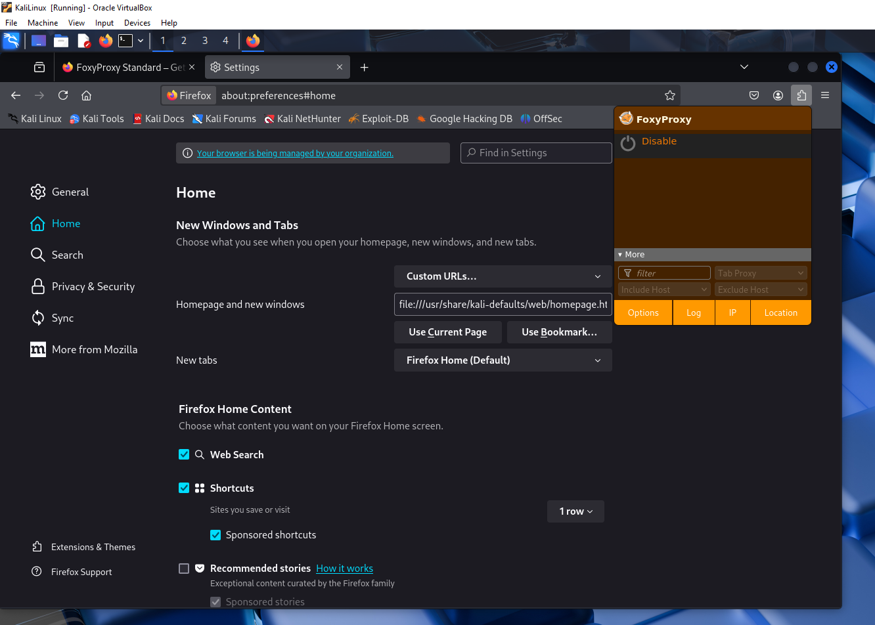

FoxyProxy is disabled by default

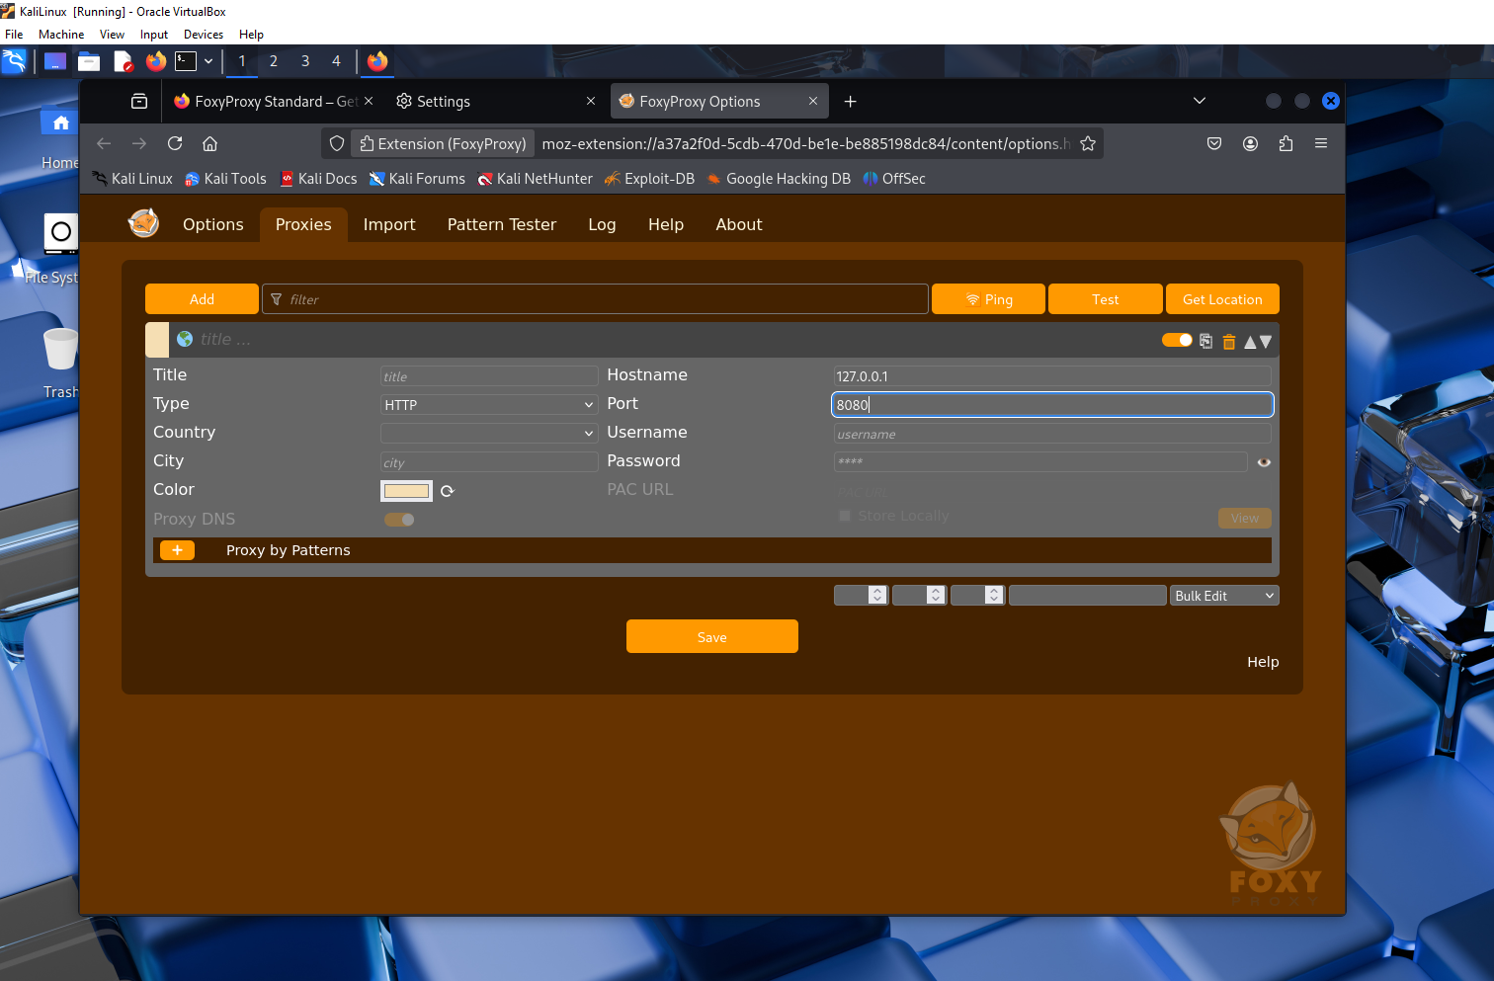Adding the Proxy with the localhost and port number

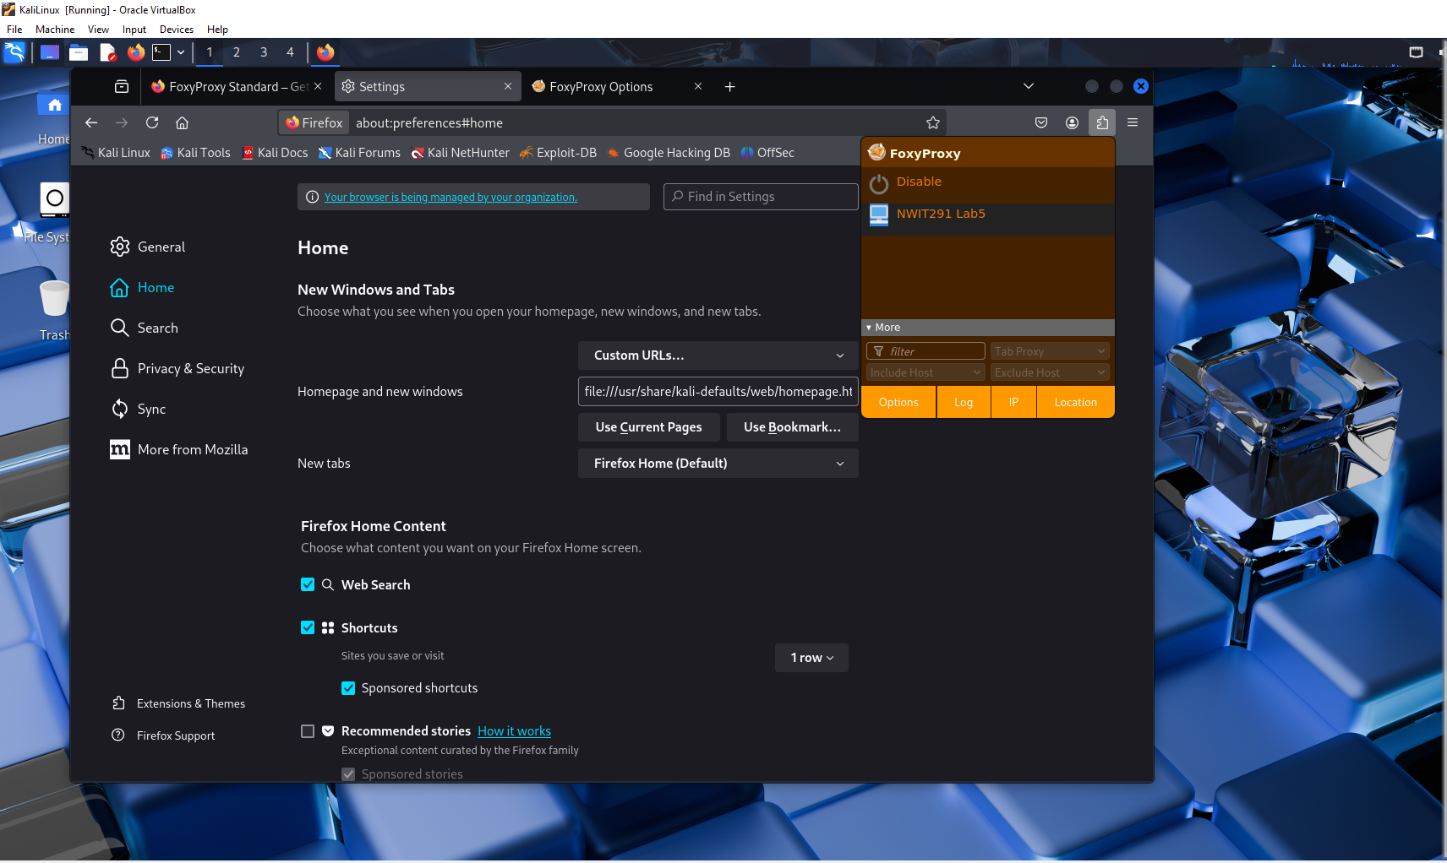

Enabled FoxyProxy with saved configuration

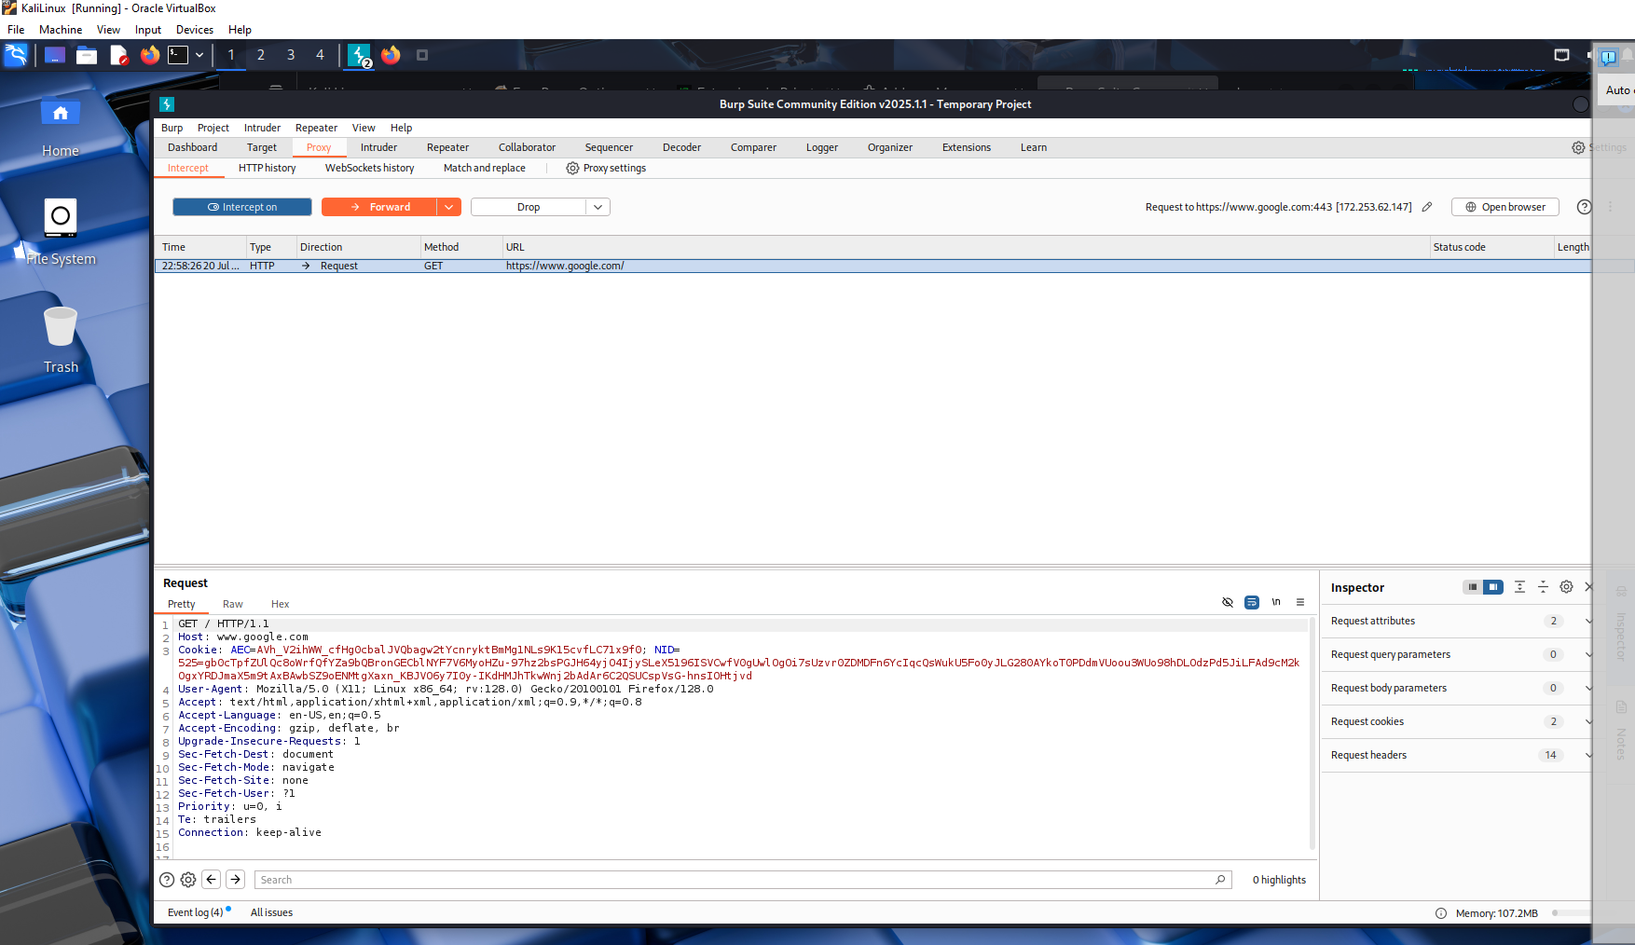

After enabling with BurpSuite and installing the CA certificate, we can intercept traffic such as going to [Google.com](http://google.com) in FireFox

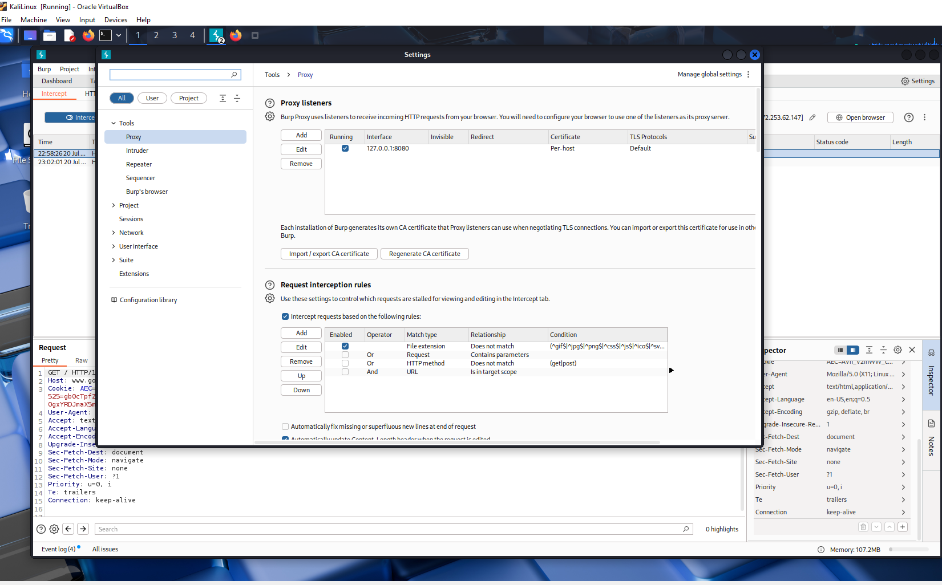

After examining, we can verify that FoxyProxy is working with BurpSuite to listen in on port 8080